**Requirement Gathering and Analysis Phase**

**Data Flow Diagram & User Stories**

|  |  |
| --- | --- |
| Date |  |
| Team ID | SWTID1720278137 |
| Project Name | Project – Online Learning Platform |
| Maximum Marks |  |

**Data Flow Diagrams:**

A Data Flow Diagram (DFD) is a traditional visual representation of the information flows within a system. A neat and clear DFD can depict the right amount of the system requirement graphically. It shows how data enters and leaves the system, what changes the information, and where data is stored.

Example: DFD Level 0 (Industry Standard)

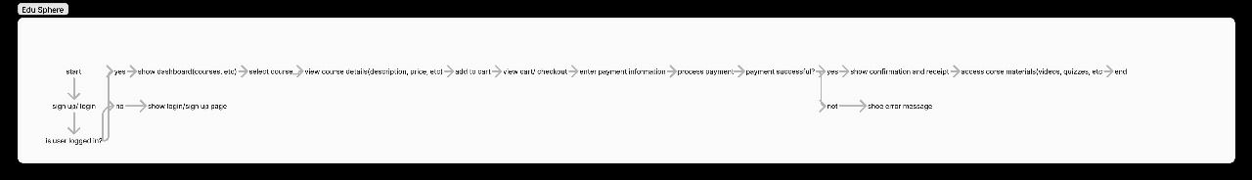

**User Stories**

Use the below template to list all the user stories for the product.

| **User Type** | **Functional Requirement (Epic)** | **User Story Number** | **User Story / Task** | **Acceptance criteria** | **Priority** | **Release** |
| --- | --- | --- | --- | --- | --- | --- |
| Customer (Mobile user) | Registration | USN-1 | As a user, I can register for the website by entering my email, password, and confirming my password. | I can access my account / dashboard | High | Sprint-1 |
|  |  | USN-2 | As a user, I will receive confirmation email once I have registered for the application | I can receive confirmation email & click confirm | High | Sprint-1 |
|  |  | USN-3 | As a user, I can register for the application through Gmail |  | Medium | Sprint-1 |
|  | Login | USN-4 | As a user, I can log into the application by entering email & password |  | High | Sprint-1 |
|  | Dashboard |  |  |  |  |  |
| Customer (Web user) | Course selection and enrolment | USN-5 | As a user, I can browse courses, view details, and enrol in courses of interest. | I can add courses to cart and proceed to checkout for enrolment. | Medium | Sprint-2 |
|  | Payment processing | USN-6 | As a user, I want a secure and seamless payment process when enrolling in paid courses. | I receive a confirmation of payment and access to the course upon successful transaction. | High | Sprint-2 |
| Customer Care Executive | Issue Tracking and Resolution | USN-7 | As a customer care executive, I want to log and track user issues so that I can resolve them efficiently. | Executives can create new issue tickets with detailed descriptions and user information, as well as update ticket statuses. | Medium | Sprint-3 |
|  | Payment and Refund Handling | USN-8 | As a customer care executive, I want to handle payment issues and process refunds so that users can have a smooth financial experience. | Executives can view user payment histories, initiate refund processes, and resolve payment disputes | Medium | Sprint-3 |
| Administrator | System Monitoring and Reporting | USN-9 | As an administrator, I want to monitor system performance and generate reports so that I can ensure the platform runs smoothly and meets user needs. | Administrators can generate and download reports on user activity, course enrolment, and financial transactions. | Medium | Sprint-4 |
|  | Content Moderation | USN-10 | As an administrator, I want to moderate user-generated content so that the platform maintains a safe and respectful learning environment. | Administrators can flag and remove inappropriate content. | Medium | Sprint-4 |
|  |  |  |  |  |  |  |
|  |  |  |  |  |  |  |